CSCI 340 Spring 2019 Networking  
Mid-term Exam  
TAKE HOME: Exam will be due on October 7th, 11:59 PM

Instructions:

* You may use your textbook, notes from class, and any presentations that I have posted for the course this semester.
* You may not discuss the exam with anyone other than me.
* I believe this exam can be completed within three hours, but you are welcome to use more time.
* Points possible: 150 points
* The exam will be available October 1st, 11:59 PM

1. (25 points total) A file of size 1 GB is being sent from host A to host B across three hops using UDP. Each packet of data is 480 bytes of data plus 20 bytes of header information. The transmission rate at host A and each router on the way is as follows: 100Mbps, 200Mbps, and 100Mbps. The propagation speed on the network is 2.5 * 108 meters per second. The first hop is 1000km, the second is 1500 km, and the third is 2000 km. (Ignore queuing and processing delay.)

R1

**Packet length L  
1 GB**

R = 100Mbps

R = 100Mbps

R = 200Mbps

B

A

R2

1500 KM

1000 KM

2000 KM

* 1. (5 points) What is the transmission delay for a **single** packet of data from A to B?

Delay(T) = (L/R) = (1x10^9/1x10^8)+(1x10^9/2x10^8)+(1x10^9/1x10^8) = 2.5x10^17

* 1. (5 points) What is the propagation delay for a **single** packet of data from A to B?

Delay(P) = (d/s) = (1x10^3 / 2.5x10^8) + (1.5x10^3/ 2.5x10^8) +(2x10^3/ 2.5x10^8) = 1.8x10^11

* 1. (5 points) How long does it take a single packet to go from host A to host B? (Hint: End to end delay.)

Delay(EtE) = Delay(T) + Delay(P) = 2.5x10^17

* 1. (5 points) How many packets will be transmitted?

# of Packets = File size / Packetsize = 1GB/ 480B = 2083334

* 1. (5 points) How long will it take the entire file to be transmitted from host A to host B? (This should build upon your previous answers.)

1. (25 points total) Let’s assume we are sending data between host A and B. The packet size of the sending node is **380** and the header is **20**. Host B is acknowledging back **100** bytes. Let’s consider the bandwidth **of 10 KB/s** (10,000 bytes per second) available on the link from **A to B** and has a propagation time of **60** msec. On our way back from **B to A**, the bandwidth is **20KB/s** and has a propagation time of **40** msec.

A->B bandwidth 10 KB  
Tp = 60 msec

B->A bandwidth 10KB  
Tp = 40

ACK = 100 bytes

1. (5 points) Based on the information above using *stop and wait* protocol, what is the transmission delay **Tt**from **A to B**?

Transmission Delay = L / R = 400 / 10x10^3 = 0.04

1. (5 points) What is the transmission delay **Tt** from **B to A**?

Transmission Delay = L / R = 100 / 20x10^3 = 0.005

1. (5 points) Based on the two different propagation delays, what is the Round Trip Time (RTT)? (**Be careful of the two different propagation delays; you can’t use 2Tp, since they are different rates**)

RTT = Tt + Tab + Tba = 0.06+0.04 + 0.04 + 0.05 = 0.19 sec

1. (5 points) What is the bandwidth utilization (efficiency)?

Tt/Tt+Tab+Tba = 0.52 = 52%

1. (5 points) What is the stop and wait throughput?

1/1+2(Tp/Tt)

1. (30 points total) Let’s assume host **A** is sending **4 TCP** segments to host **B** (window size is 4). After the initial 3 way handshake, the **first** segment’s sequence number is **60**, the **second** sequence number is **80**, and the **third** is **110**. The last sequence number is 150 + 40 bytes of data. (Hint: Drawing a diagram may help you solve this more easily.)
   1. (5 points) How much data is in the first, second and the third segments?

1St: 20 bytes (80-60)

2nd: 30bytes (110-80)

3rd: 80 bytes (150-110 + 40 bytes)

* 1. (5 points) If there is no data loss, what are the acknowledgement numbers that A is going to receive?

1St: 61

2nd: 81

3rd: 111

* 1. (5 points) Let’s assume that the second packet was lost, and you are still within the timeout window. What is the ACK number received for the third packet?

110. The ack number in an error is the same as the sequence number you last recieved

* 1. (5 points) If you are using the GBN protocol, in the above scenario (c), what would the host A do after the timeout period? Explain your answer (include a diagram) and give a scenario that would fit GBN protocol compared to SR protocol.

If packets are received out of order, we do not send anything back and wait for a timeout, when there is a timeout with no ACK, the packets are sent again (those that have not been ack)

* + 1. How many total packets will be transferred using the GBN protocol?

Depends on the window side which we do not know3.

* 1. (5 points) What would happen if you are using the SR protocol and the first packet is lost and you are now receiving 3 acknowledgment numbers equal to 80 (Assume you are still within the timeout period.)? Give a scenario that would best fit the SR protocol.

The acks would return to the sender and after 3 it would realize that a packet is lost and resend the whole window.

* + 1. How many total packets will be transferred using the SR protocol?

Depends on how large the window size is.

1. (10 points) Consider the three 16-bit words (shown in binary) below.
   1. Compute the Internet checksum value for these three 16-bit words:
   2. Validate the checksum.

11101001 10110110

00011001 10010010

Take compliment and then add the third

11101001 10110111

|  |  |  |  |  |  |  |  |  |  |  |  |  |  |  |  |
| --- | --- | --- | --- | --- | --- | --- | --- | --- | --- | --- | --- | --- | --- | --- | --- |
| 1 | 1 | 1 | 0 | 1 | 0 | 0 | 1 | 1 | 0 | 1 | 1 | 0 | 1 | 1 | 0 |
| 0 | 0 | 0 | 1 | 1 | 0 | 0 | 1 | 1 | 0 | 0 | 1 | 0 | 0 | 1 | 0 |
| 0 | 0 | 0 | 0 | 0 | 0 | 1 | 1 | 0 | 0 | 1 | 0 | 1 | 0 | 0 | 1 |
| 1 | 1 | 1 | 0 | 1 | 0 | 0 | 1 | 1 | 0 | 1 | 1 | 0 | 1 | 1 | 1 |
| 1 | 1 | 1 | 0 | 1 | 1 | 0 | 1 | 0 | 0 | 0 | 0 | 0 | 0 | 0 | 0 |

Check sum is not valid, there is an error. Validation needs to now be

0001001011111111

1. (10 points) My friend uses Gmail to read and send email through a web browser. She sends mail to my Xavier account, where I have my Outlook set up to use IMAP to get my mail from Xavier's mail server.
   1. Draw a clear sender and receiver process from the point she opens her browser to the point of me reading the mail.
   2. Explain which network protocols are being used, at each step, to make this communication possible.

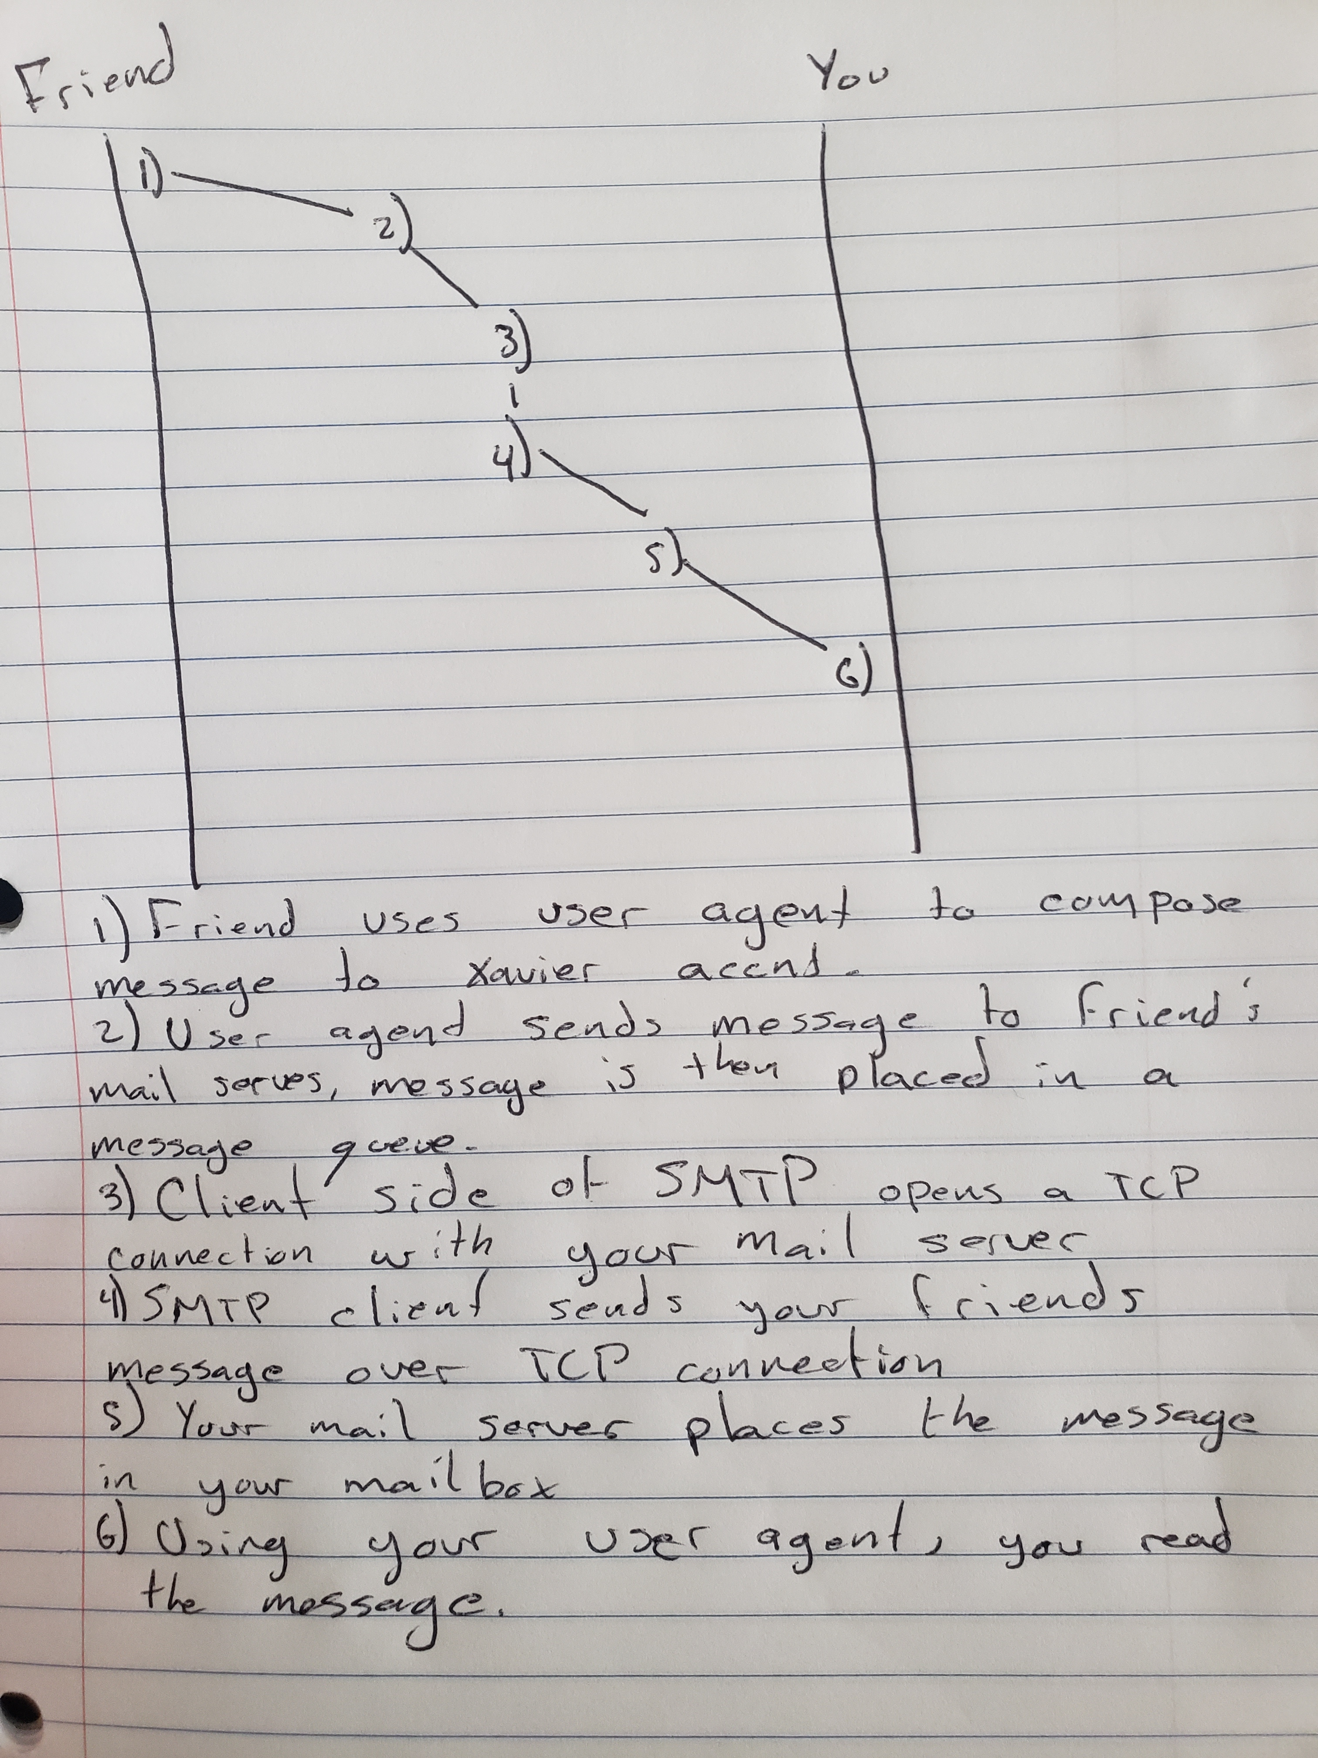

1. (10 points) Suppose the file has references to a JavaScript file of length 4K bytes and an embedded image size of 5MB. Each of these files needs to be brought over from the server in order for the client to display the page properly. A new HTTP protocol, HTTP/2, allows the server to push content, that is, to respond with data for more queries than the client requested. This allows the server to supply data it knows to a web browser (e.g., the JavaScript file and the image), without waiting for the browser to examine the first response, and without the overhead of an additional request cycle. (You will have to do some research online for this one.)
   1. How does HTTP/2 differ from the HTTP/1.1 protocol we studied?

HTTP/1.1 uses text-based commands to process and run their HTTP requests while HTTP/2 uses binary and is also able to support query multiplexing, headers compression, and better packet stream management.

* 1. How might it impact the overall time for a client to receive all of the files associated with its request?

Since HTTP2 has a better packet stream management, this leads to reduced latency which helps packets transport faster.

* 1. Are there any security benefits?

HTTP2 includes security benefits as well as compression features are safer.

1. (20 points) TCP Congestion Control Graph: Your TCP-Reno algorithm is sending data, beginning in a slow start with a congestion window of size **1MSS** and **SSThresh** of **16MSS**. Draw a graph of congestion window size (y-axis) vs time unit in RTT (x-axis) describing the following situation:
   1. A timeout occurs at the end of the 9th transmission round.
   2. Triple duplicate ACK occurs at the end of the 15th transmission round.
   3. The packet is successfully acknowledged at the 20th transmission round and packets are then sent for 2 more rounds.

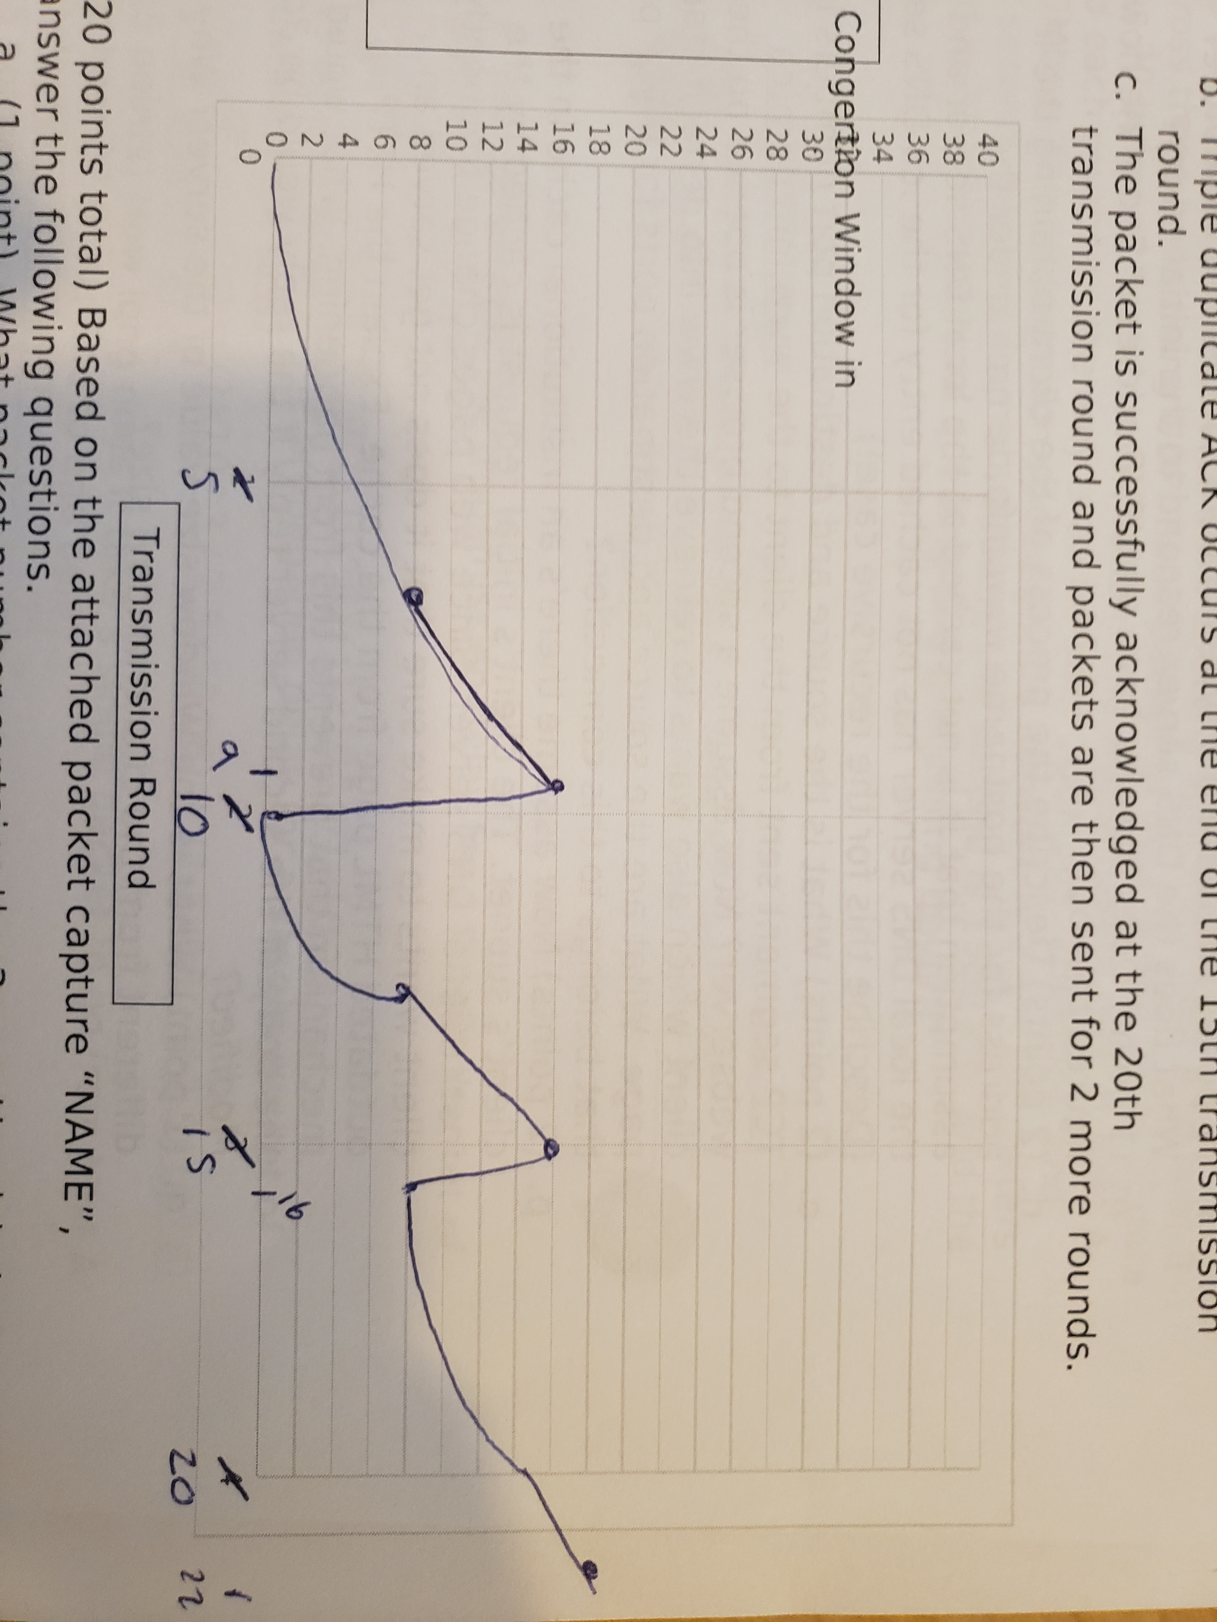



Congertion Window in segments

Transmission Round

1. (20 points total) Based on the attached packet capture “NAME”, answer the following questions.
   1. (1 point) What packet number contains the 3-way Handshake?

The 3 way handshake is included in packet number 7.

* 1. (1 point) What is the name of the file that is being retrieved in this GET message?

The name is Technical.html

* 1. (1 point) What version of HTTP is the client running?

The client is running HTTP1.1

* 1. (1 point) What is the client's preferred version of English? What is the browser's least preferred version of English?

Accept-Language: en-US,en;q=0.5\r\n

This means it would prefer US English but will accept other types of English.

* 1. (1 point) What is the type of client browser and the client's operating system?

The browser is Mozilla Firefox and is on a Linux OS

User-Agent: Mozilla/5.0 (X11; Linux x86_64; rv:60.0) Gecko/20100101 Firefox/60.0\r\n

* 1. (1 point) Is the response message using HTTP 1.0 or HTTP 1.1? Explain.

It replied OK(200) as the response using HTTP 1.1

* 1. (1 point) Was the server able to send the document successfully? Explain.

Yes. The responses were all OK(200)

* 1. (1 point) At what date and time was this response sent?

* 1. (1 point) How many bytes are there in the document being returned by the server?

1669 bytes

* 1. (1 point) What is the default mode of connection for HTTP protocol? Is the connection reply persistent or non-persistent? Explain.

The default for HTTP1.1 is persistent. Here the connection is non-persistent as it has the header Connection: close\r\n

* 1. (1 point) What is the name of the server and its version?

The server is Apache

* 1. (1 point) What are the types of DNS queries in this capture? What does the DNS server respond to the initial query?

The types of queries include IPv4, IPv6, and Canonical Names

The DNS server responds with no error

* 1. (1 point) Does the site have and IPV6 address? Show me how you figured this out.

Yes, You can tell by the AAAA

* 1. (2 points) Describe the process of the client obtaining the IP address for the hostname www.info.dern.ch under the assumption that it is not cached at the local DNS server and that the local DNS server has not cached entry for the .ch DNS server. (Describe this for the recursive case!)

When the DHCP server recieves the proper request from our client, an acknowledgment package (DHCPACK) is sent back to the client which is sending the configuration information.

* 1. (2 points) What is the source and destination port numbers in a TCP segment sent from the client to the [www.info.dern.ch](http://www.info.dern.ch/) webserver? Now assume a second browser is opened on the client which also wants to retrieve the www.info.dern.ch start page. What are the source and destination ports for a TCP packet that belongs to this connection?

First part of the question is as below. For the second part of the question the source and destination ports are just flipped.

Source: 53500

Destination: 80

* 1. (2 points) Now assume there’s an institutional cache in the client’s subnet. The client’s initial request is cached by the institutional DNS server. Since web pages change frequently, the client wants to make sure that it does not get served an outdated HTML page from the cache. Explain the HTTP mechanism that prevents this from happening. What would be in the body of the second server reply if the reply would be *304 Not Modified*?
  2. (1 point) What is the Window size value of the server? Why is it different from the client window size?

The window size of the server is 64240, it is different than the client window size because it needs to be larger to handle more requests.